Low Pass Filter having Frequency 1000 Hz

Assuming Resistance - 1k ohm

Capacitance Value - 0.16 µF

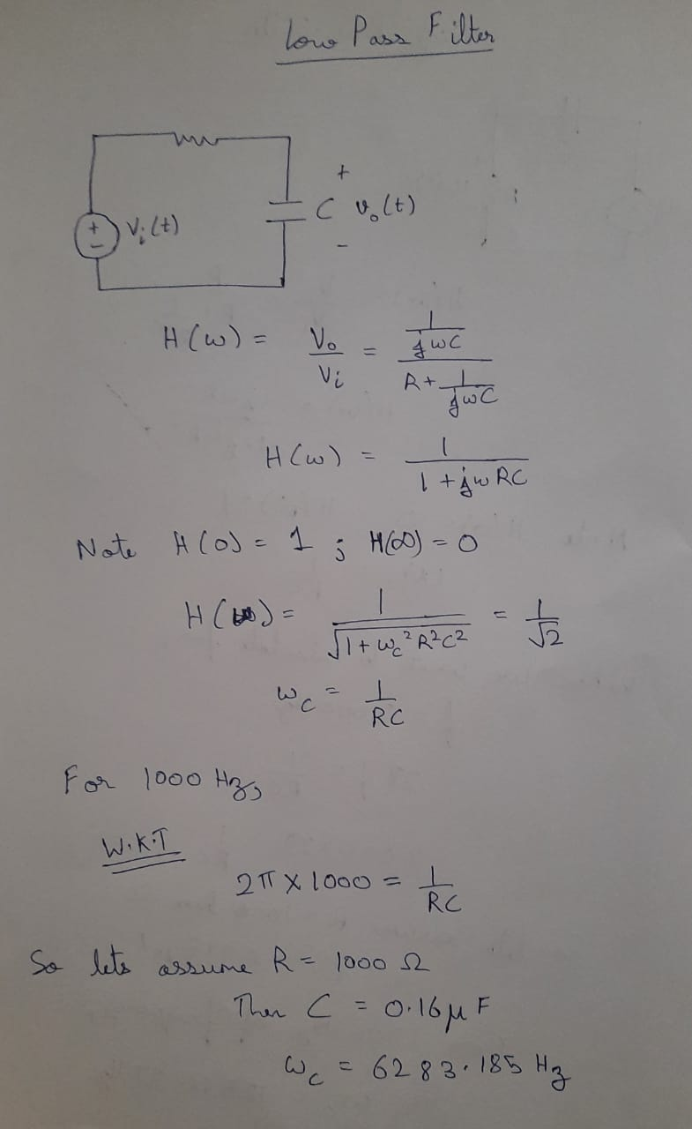

Circuit: -

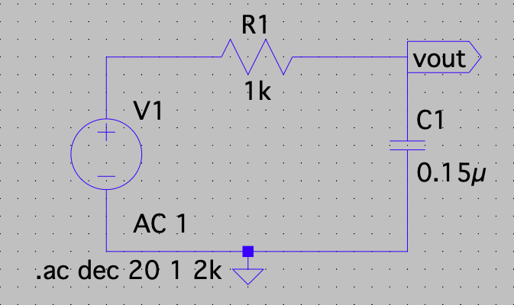

Graph: -

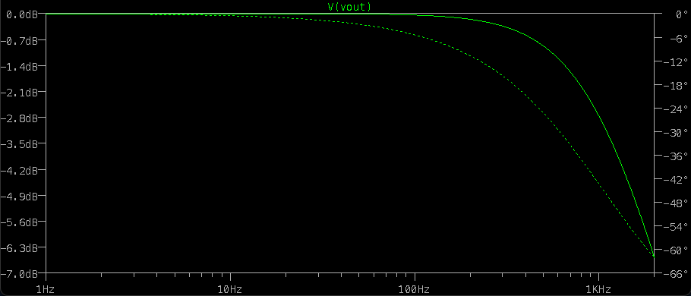

Graph with Axis: -

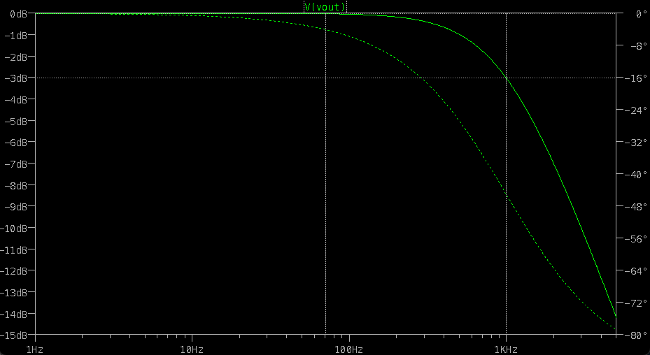

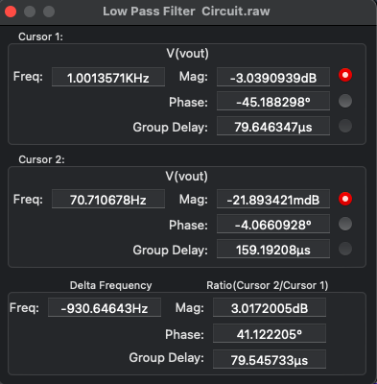

High Pass Filter having Frequency 2000 Hz

Assuming resistance - 100 ohm

Capacitance Value - 0.795 µF

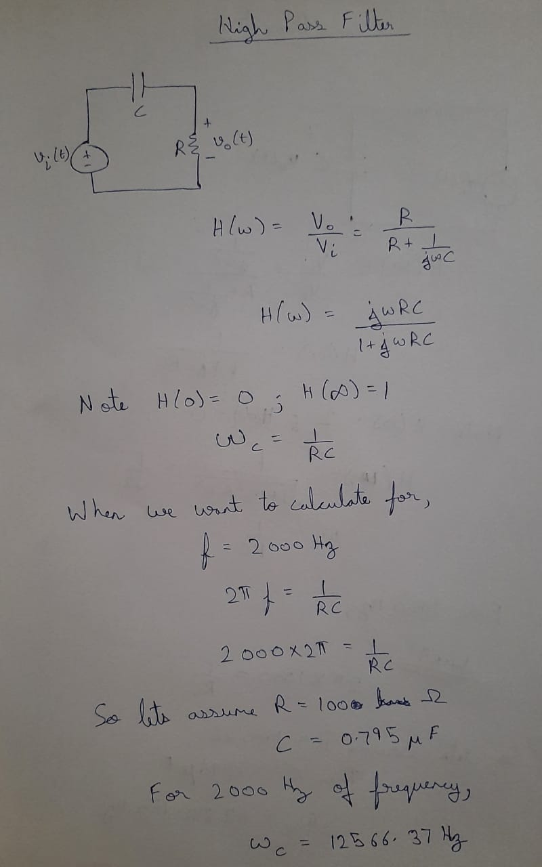

Circuit: -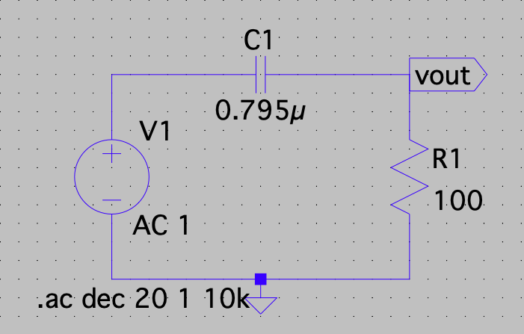

Graph: -

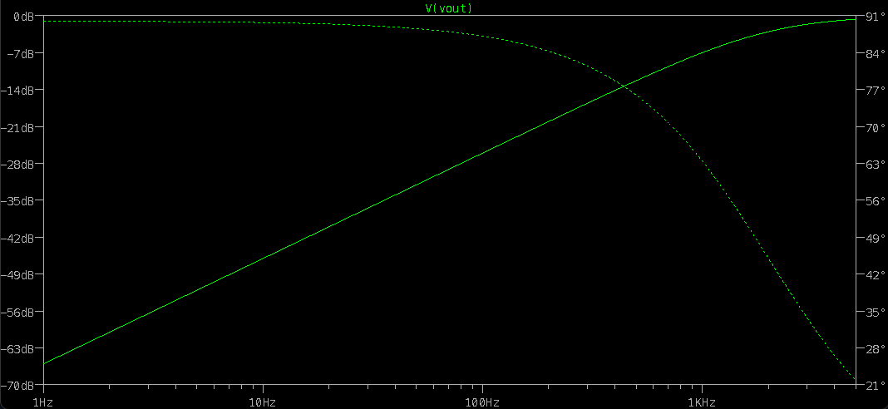

Graph with Axis: -

